Stress Reliever Ideas/Suggestions
- Don’t skip breakfast
A good Breakfast gives you a head start for the day. When you have loads and loads of daily work you definitely need the energy to accomplish your goals perfectly and especially on time, for that you need a wholesome breakfast. Breakfast should be a healthy one, to try some good recipes which will also help you relieve stress and give you the power for the day visit: https://www.hrtwarming.com/stress-relieving-foods-vegetables-fruits/.

- Go Walking
Walking for even 10 min at work after every 3 hours uplifts your mood. Walking will not only make you live longer but also keep you way more energetic for the day.

- Active Sitting
To help your body while you are seated rethink your sitting with “active sitting”. Conventional chairs provide active support. Active sitting lets your body do more of the work. Conventional chairs will improve your posture too.

- Listen To Music
Music has a magical element. The different beats in music enhance your mood and help to relax your muscles. Your mind responds to the beats of the music you are hearing which helps relax you and lightens your mood.

- Healthy Snacks
Food is really a deciding factor of your stress level, if you eat healthy at work it will not only make you feel less stressed but make you more productive and energetic. A green diet helps to bring positive changes to your mood and which will send out positive vibes.

- Massages
Massages are a very good method of relieving stress from your mind and body. Their are various types of massages which can help to alleviate stress. A simple and easy way is to keep two golf balls at your desk. Whenever you feel a little stressed, just slip off your shoes and roll the balls with your feet.

- Smiling
Smiling is the basic rule for being stress free. If you smile your co-workers will almost always smile back, which creates a very positive mood throughout the work place. Less negativity means more productivity.
- Stretch Your Body Regularly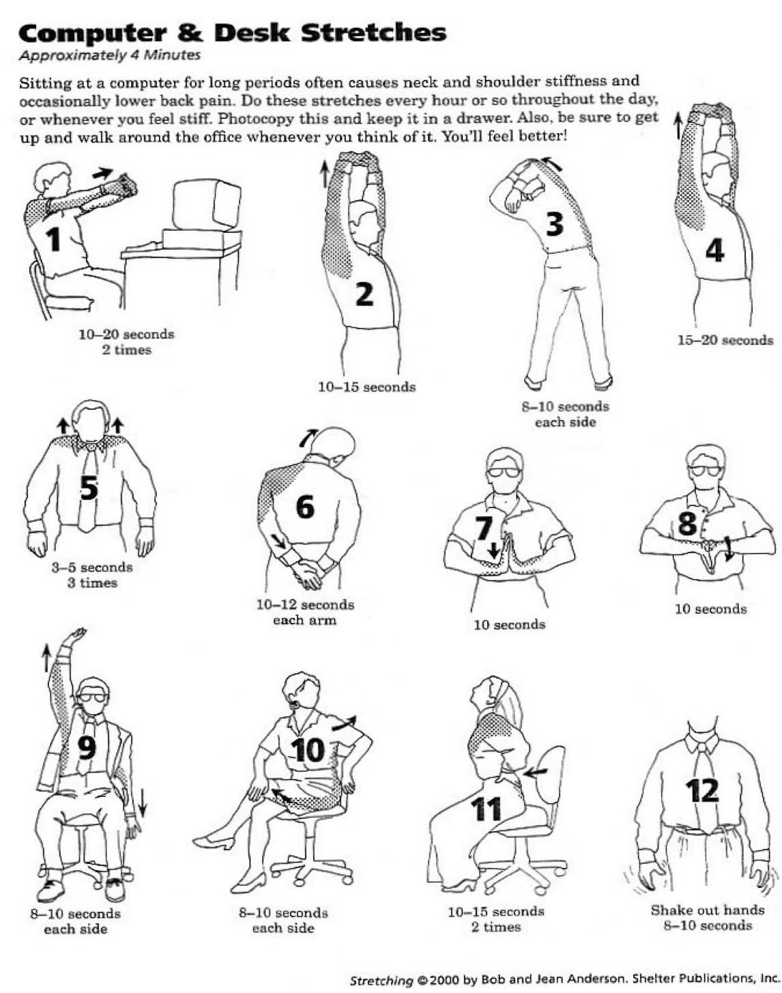

- Yoga and breathing exercises
Yoga and breathing exercise are some of the oldest techniques of relieving stress and being fit. There are numerous classes and videos that show you the proper and simple techniques of Yoga and proper breathing.

- Keep loved one pictures nearby
Why do you work hard, it is not only for yourself but for your family as well. Spending time with your family is a great stress buster, so pictures placed in your work area or in your locker will boost you and your working skills throughout the day.

- A quick nap
A quick nap for just 10 - 15 minutes at your lunch break can do wonders to your health and will leave you feeling more energetic and productive.

